Name: Adarsh Khokale
Email: adarshkhokale@gmail.com
Phone No.: 9844995544
Topic: Airbnb Data Analysis
GitHub Link: https://github.com/adarshkhokale-gif/Airbnb_Data_Analysis.git

1. Introduction and Objective
The primary objective of this project is to analyze an Airbnb dataset to uncover insights into key business metrics such as pricing, property distribution, room-type popularity, guest reviews, and property availability. To make these insights accessible and actionable, an interactive dashboard was developed to allow users to dynamically explore the data through location-based context, customized filtering, and real-time visualizations.

2. Dataset and Preprocessing
- Source & City: The data was sourced from Inside Airbnb, specifically focusing on Albany, NY.
- Collection Date: The data scrape was conducted on June 16, 2026.
- Dataset Dimensions: The initial "listings.csv" dataset contains 490 rows and 90 columns.
- Missing-Value Treatment: Missing numerical values were handled via median imputation, while missing categorical variables were filled with an explicit "Unknown" label.
- Duplicate Removal: An initial check confirmed there were 0 duplicate rows, ensuring data uniqueness before analysis.
- Price Conversion: The price column was originally formatted as a string with currency symbols. It was preprocessed by stripping out the dollar signs ($) and commas (,), and then converted into a numeric float data type to enable quantitative analysis.

3. Exploratory Data Analysis
Based on the data exploration of "listings.csv", the following visual analyses were conducted:
- Price Distribution: The nightly price distribution is right-skewed, with the vast majority of properties priced between $50 and $200 per night. The mean price across the dataset is $165.57, while the median sits slightly lower at $145.00.
- Room-Type Counts: There is a heavy preference for full-property rentals. "Entire home/apt" is the dominant category with 345 listings, followed by "Private room" with 135 listings. "Hotel room" (9) and "Shared room" (1) make up a negligible portion of the market.
- Neighborhood Comparisons: The "SIXTH WARD" is the most popular neighborhood by a significant margin, hosting over 110 listings. This is followed by the "TENTH WARD" and "THIRD WARD," which hover around 40-50 listings each.
- Scatter Plot (Price vs. Reviews): Comparing nightly prices against the number of reviews reveals a distinct pattern: lower-priced properties (under $200) tend to accumulate the highest volume of reviews, indicating higher booking frequency or wider mass-market appeal. High-priced luxury properties see significantly fewer reviews.
- Correlation Heatmap: The heatmap shows a strong positive correlation ($r = 0.71$) between price and accommodates, confirming that property capacity is the primary driver of nightly rates. reviews_per_month and number_of_reviews also share a logical strong correlation ($r = 0.68$).

4. Key Findings and Recommendations
- Pricing Strategy: Because capacity (accommodates) heavily dictates price, hosts should benchmark their nightly rates primarily against properties of the exact same size rather than just neighborhood averages.
- Location & Supply: The Sixth Ward is the undisputed center of Albany's Airbnb market. Hosts looking to list in this area must rely on high review scores or competitive pricing to stand out in a saturated market, whereas hosts in underrepresented wards might leverage scarcity to maintain steady pricing.
- Reviews as a Conversion Tool: The data shows a concentration of high review volumes in the more affordable tiers. To increase bookings, new hosts should consider pricing slightly below the neighborhood median to rapidly build a strong foundation of positive reviews, which serves as social proof for future guests.

5. Dashboard Implementation
The interactive dashboard was built using Streamlit and implemented in "app.py". It features:
- Interactive Filters: Users can narrow down the data using sidebar filters for specific neighborhoods, room types, and a dual-ended nightly price range slider.
- Key Performance Indicators (KPIs): The top of the dashboard dynamically displays Total Listings, Average Nightly Price, Average Rating, and Average Available Nights based on the user's active filters.
- Visualizations: Utilizing Plotly, the dashboard includes a horizontal bar chart for top neighborhoods, a pie chart for room-type distribution, a histogram for price distributions, a bar chart for median prices by room type, and a scatter plot visualizing price versus review counts.
- Geospatial Map: A map plots the exact latitude and longitude of up to 5,000 filtered listings to allow users to explore pricing and reviews in a location-based context.
- Data Table & CSV Export: A raw data table showcases key property details (ID, name, neighborhood, price, minimum nights, etc.), accompanied by a one-click button allowing users to export the filtered dataset to CSV format for external use.

6. Conclusion and Limitations
The analysis and resulting dashboard successfully provide a comprehensive overview of the Albany Airbnb market, highlighting the concentration of listings in the Sixth Ward and the strong relationship between property capacity and pricing.
However, the analysis has limitations. The availability_365 metric only indicates unbooked calendar nights and cannot be directly translated to confirmed occupancy or exact revenue. Additionally, while we have review volume and ratings, the absence of natural language processing on the actual "reviews.csv" prevents a deeper sentiment analysis of what guests explicitly liked or disliked. Future iterations of this project could improve the dashboard by implementing machine learning clustering (e.g., k-means) to group similar properties, or predictive models to recommend optimal pricing algorithms for hosts based on location and room type.

Charts
  - Correlation Heatmap
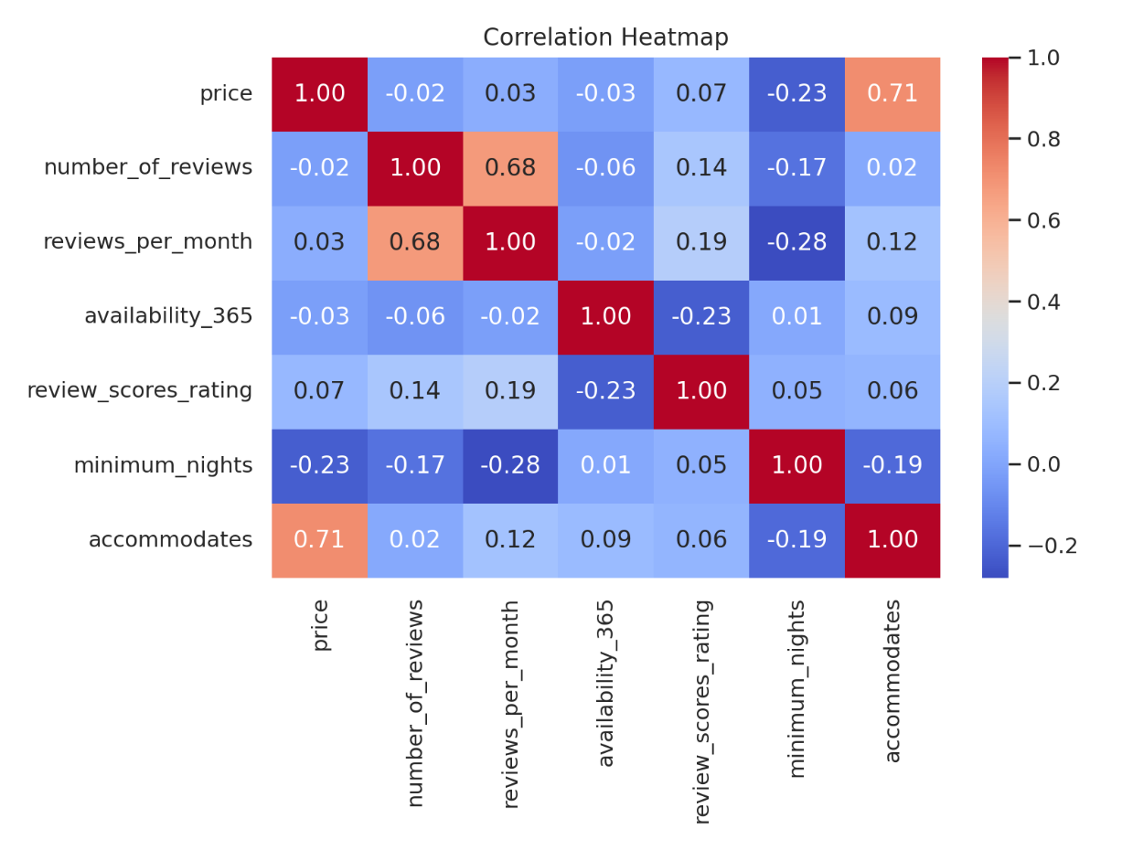
  - Nightly Price vs Number of reviews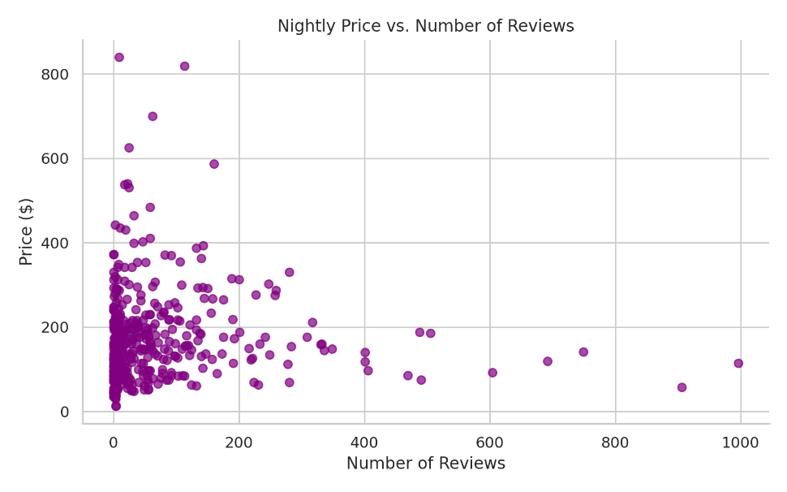

  - Top 10 Neighborhoods by Listings counts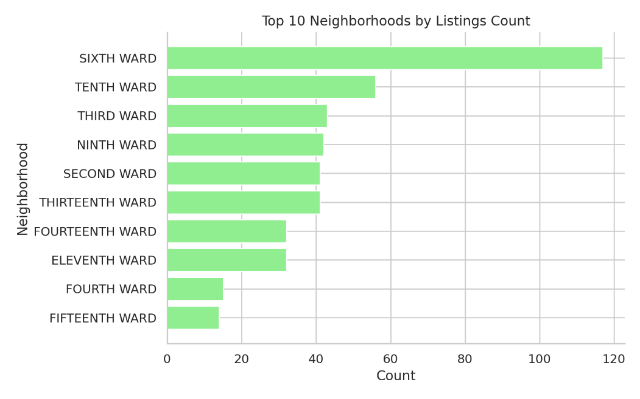

  - Listings by Room Type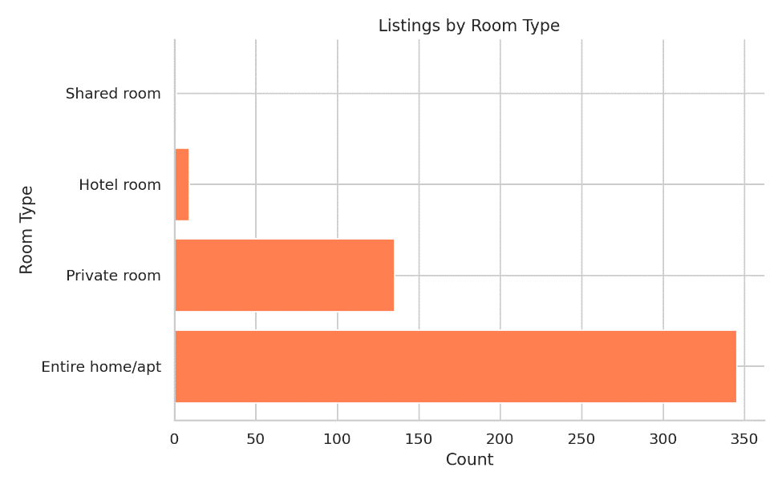

  - Nightly Price Distribution